

**OCT2022**





|  |  |  |
| --- | --- | --- |
| **CHAPTER NO.** | **TITLE** | **PAGE NO.** |
| 1 | **CHAPTER-1:**  **PROJECT DESCRIPTION AND OUTLINE**   * 1. Introduction   1.2 Motivation for the work  1.3 [About Introduction to the project  including techniques]  1.5 Problem Statement  1.6 Objective of the work  1.7 Organization of the project  1.8 Summary | 1  .  .  . |
| 2 | **CHAPTER-2:**  **RELATED WORK INVESTIGATION**  2.1 Introduction  2.2 <Core area of the project>  2.3 Existing Approaches/Methods  2.3.1 Approaches/Methods -1  2.3.2 Approaches/Methods -2  2.3.3 Approaches/Methods -3  2.4 <Pros and cons of the stated Approaches/Methods >  2.5 Issues/observations from investigation  2.6 Summary |  |
| 3 | **CHAPTER-3:**  **REQUIREMENT ARTIFACTS**  3.1 Introduction  3.2 Hardware and Software requirements  3.3 Specific Project requirements  3.3.1 Data requirement  3.3.2 Functions requirement  3.3.3 Performance and security requirement  3.3.4 Look and Feel Requirements  3.3.5 ………  3.4 Summary |  |
| 4 | **CHAPTER-4:**  **DESIGN METHODOLOGY AND ITS NOVELTY**  4.1 Methodology and goal  4.2 Functional modules design and analysis  4.3 Software Architectural designs  4.4 Subsystem services  4.5 User Interface designs  4.5 ………………..  4.6 Summary |  |
| 5 | **CHAPTER-5:**  **TECHNICAL IMPLEMENTATION & ANALYSIS**  5.1Outline  5.2 Technical coding and code solutions  5.3 Working Layout of Forms  5.4 Prototype submission  5.5 Test and validation  5.6 Performance Analysis(Graphs/Charts)  5.7 Summary |  |
| 6 | **CHAPTER-6:**  **PROJECT OUTCOME AND APPLICABILITY**  6.1Outline  6.2 key implementations outlines of the System  6.3 Significant project outcomes  6.4 Project applicability on Real-world applications  6.4 Inference |  |
| 7 | **CHAPTER-7:**  **CONCLUSIONS AND RECOMMENDATION**  7.1Outline  7.2 Limitation/Constraints of the System  7.3 Future Enhancements  7.4 Inference |  |
|  |  |  |

# INTRODUCTION

A Translator or language translation program is a software application or service that translates text or speech from one language to another. Translators can also interpret programming code, converting it to instructions that a computer can understand and execute. For example, a compiler is an example of a translator that takes a programming language (e.g., C++) and translates into machine language or assembly language the computer can understand.Automatic translator software systems use sophisticated translation technology with comprehensive dictionaries and a collection of linguistic rules that translate one language into another without relying on human translators. An automatic translator software system interprets the structure of sentences in the source language (the language the user is translating from) and generates a translation based on the rules of the target language (the language the user is translating to). The process involves breaking down complex and varying sentence structures; identifying parts of speech; resolving ambiguities; and synthesizing the information into the components and structure of the new language.

**FUTURE OF TRANSLATOR IN ARTIFICIAL INTELLIGENCE**

AI translation tools are great for self-study and for use as classroom aids, but a lot of the time the translations they produce need to be checked by a real person as they sometimes make obvious mistakes. They also lack the human element; while you’re travelling abroad, they can be very useful in emergency situations – for example when you need to look up a word or order something from the pharmacy. But it’s not easy to build relationships and survive using only digital translators using a text or voice translator. While we’ve always had human translators, we don’t use them in place of our educators. To help build relationships we need teachers; we need them to help us learn the language, not just understand it. They help guide us and give us the cultural background in a way that a computer cannot

## • RELATED WORK INVESTIGATION

As the world is increasing globally, translation is becoming more and more important. Strong communication among different type of industries is key, and the importance of translators is rising. Think about the close relationship between business, media and science, for example.

Today’s world is inter-connected and effective translation is essential in all areas. Accurate translation helps to cross a communication gap that could exist between buyer and seller Text translation from one language to another is increasingly becoming common for various websites as they cater to an international audience.

The python package which helps us do this is called translate.

This package can be installed by the following way. It provides

translation for major language

**An example** of translating a simple sentence from English to German.

The default from language being English. from translate import Translator translator= Translator (to_lang=

"German")

translation = translator. Translate("Good Morning!")print translation

When we run the above program, we get the following output Guten Morgen!

## • DESIGN METHODOLOGY AND ITS NOVELTY

### 1. WEB DEVELOPMENT (HTML, CSS, JAVASCRIPT)

To build this Language Translator App in JavaScript. First, We need to create four Files: HTML, CSS & JavaScript Files. create an HTML file with the name index.html and started the given codes into your HTML file. and we’ve to create a file with .html extension.

Second, create a CSS file with the name of style.css and paste the given codes in your CSS file. Remember, you’ve to create a file with .CSS extension.

Third, create a JavaScript file with the name of countries.js and paste the given codes in your JavaScript file. Remember, you’ve to create a file with .is extension. In this file, we’re storing supported countries as an object. Last, create a JavaScript file with the name of script.js and paste the given codes in your JavaScript file. Remember, you’ve to create a file with .is extension.

That’s all, now you’ve successfully built a Language

Translator in HTML CSS & JavaScript

#### 2. APP DEVELOPMENT (FLUTTER)

Flutter is well known for its compatibility among other mobile development platforms that why it is one of the most readily growing platforms, and the main reason behind it is the Flutter has come up with every feature and functionality which is required to develop a fully-fledged app. As you know an app is called best app if the user of it does need to access another resource to get its task done and flutter is here to meet all parameters

## • REQUIREMENT ARTIFACTS

Language translation software is used to translate documents from one human language to another. There are three basic types of products: automatic, on the-fly, and hybrid. Automatic translation software or global translation software is designed to translate an entire document at one time. These machine translation (MT) applications are used mainly with longer documents and may provide multi language translation. On-the-fly translation software is used to transfer individual words or phrases, typically in shorter documents such as Web pages or email. Hybrid products are not pure translation programs, but provide translation-related tools such as a verb conjugator, dictionary, and spell checker

Key features

1. Terminology management
2. Workflow management
3. Translation quality assurance
4. Localisation automation
5. Integration with a variety of CMSs and developer’s tools
6. Translating via API
7. Project management automation

• **PROJECT OUTCOME AND APPLICABILITY**

## a) WEB DEVELOPMENT

This is the main index page which is connected to the style.css file for styling and translate.js for the logical operations in the website.

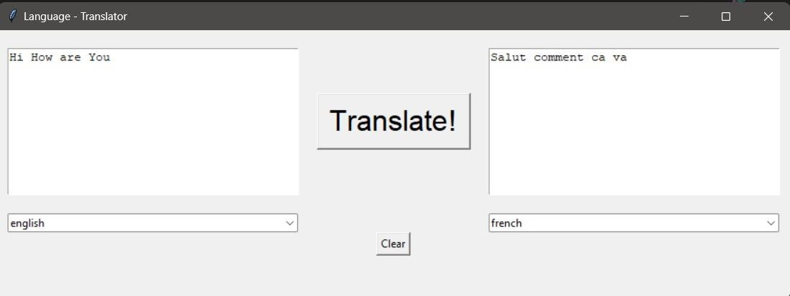

## b) APP DEVELOPMENT

We will be building a simple application in which we will be showing an EditText field and we will add any input to that TextField. Along with that, we will be displaying a Button to translate that text to the German language.

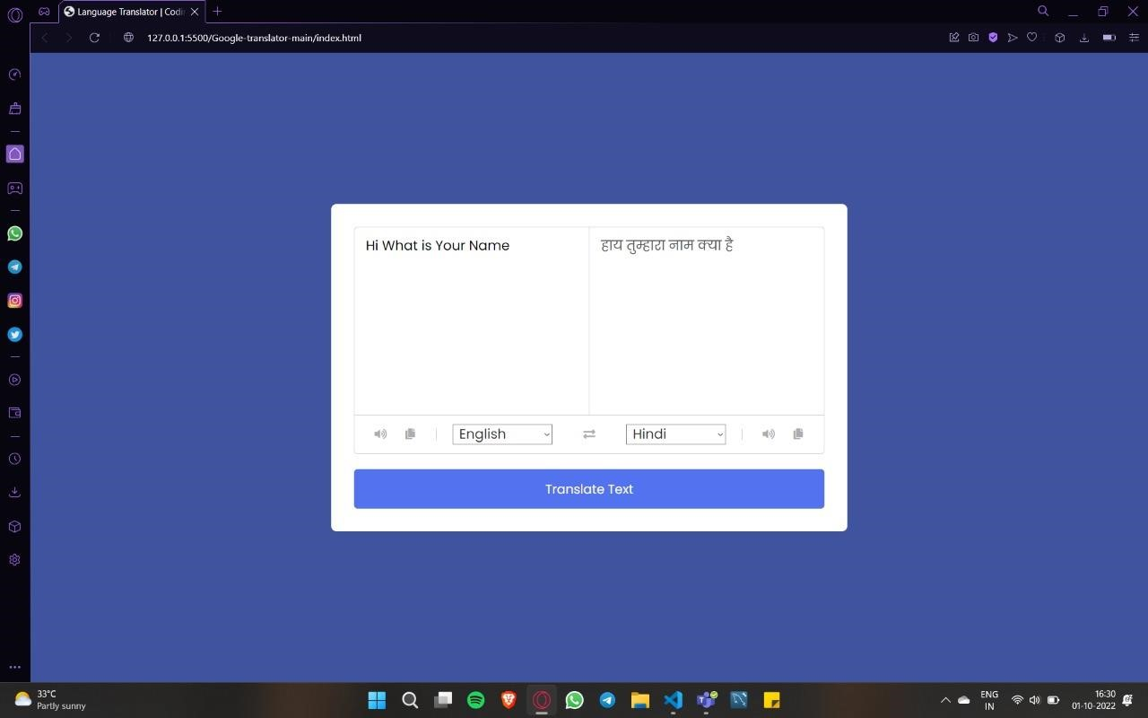

# • CONCLUSION

Summing up the entire research work done, we can now conclude that this approach of developing such a software would lead to a more advanced and user-friendly system for interaction and communication. Having done a vivid study on this topic, emphasis must be given on the development and implementation of such system software. With the increase in population, in the near future necessity would be the development of such a software. So why not to focus on this now. Hence, after considering the necessity of the present and the need for the future generations, we can now look towards the implementation of such system software